1. Operators in Python
1.1 Arithmetic Operators
Arithmetic operators are used to perform basic mathematical operations on variables and values.
- Addition (+)
Adds two numbers together.
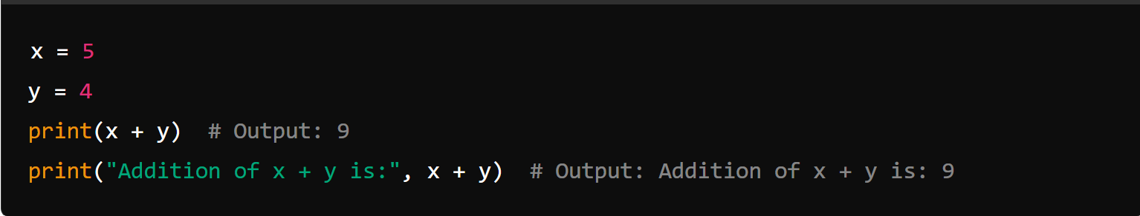

- Subtraction (-)
Subtracts the second number from the first.
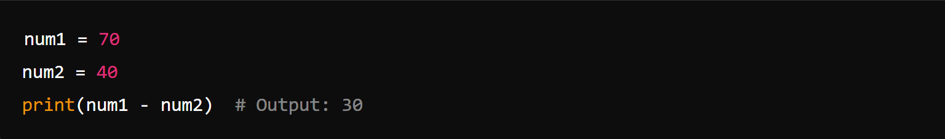
- Multiplication (*)
Multiplies two numbers together.
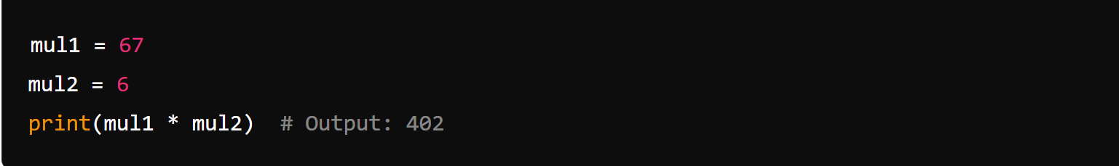
- Division (/)
Divides the first number by the second. Returns a float.
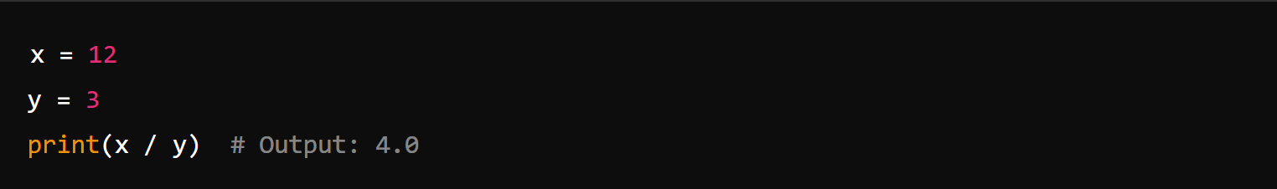

- Modulus (%)
Returns the remainder of the division.
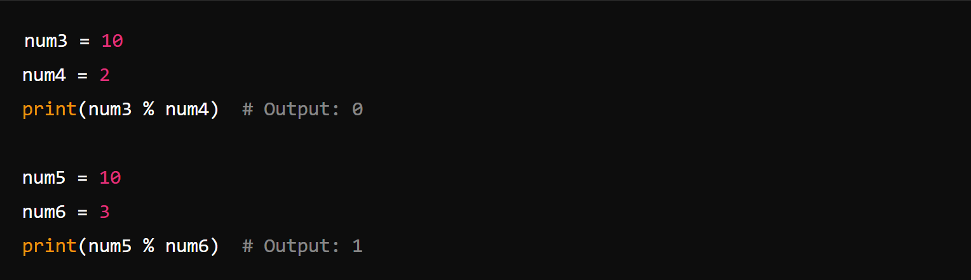
- Floor Division (//)
Divides the first number by the second and removes the decimal part.

1.2 Assignment Operators
Assignment operators are used to assign values to variables.
- Basic Assignment (=)
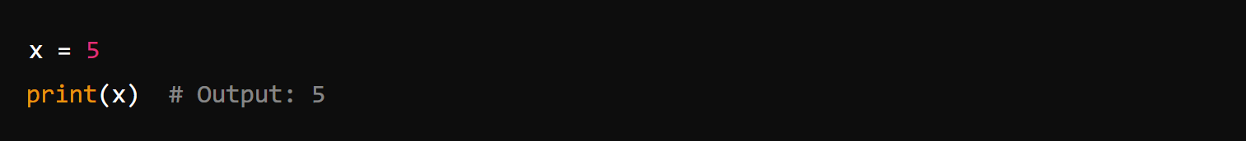
- Addition Assignment (+=)
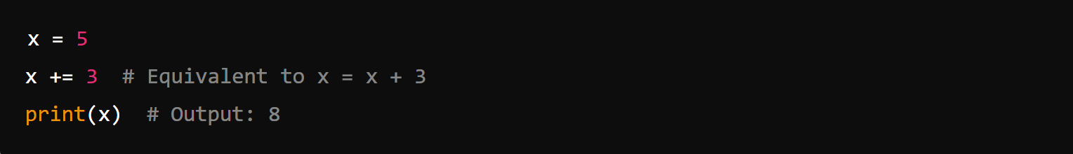
- Subtraction Assignment (-=)
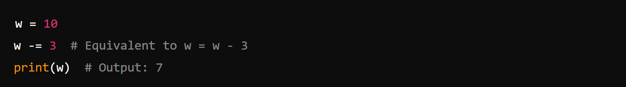

- Multiplication Assignment (*=)
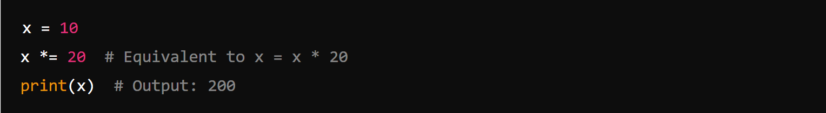

1.3 Comparison Operators
Comparison operators are used to compare two values and return a Boolean result.
- Equal to (==)
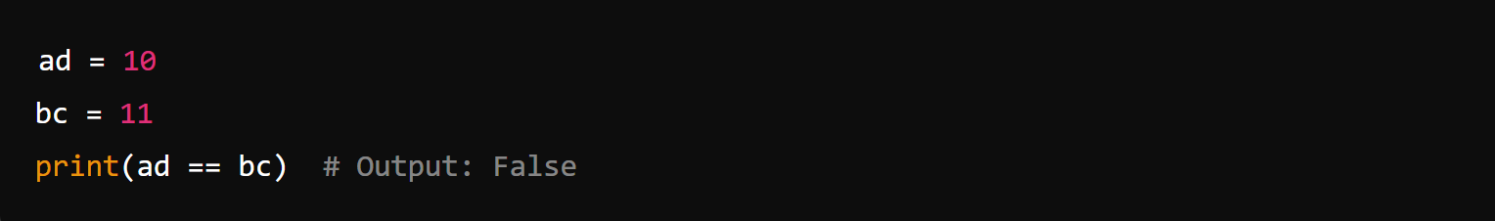
- Not Equal to (!=)
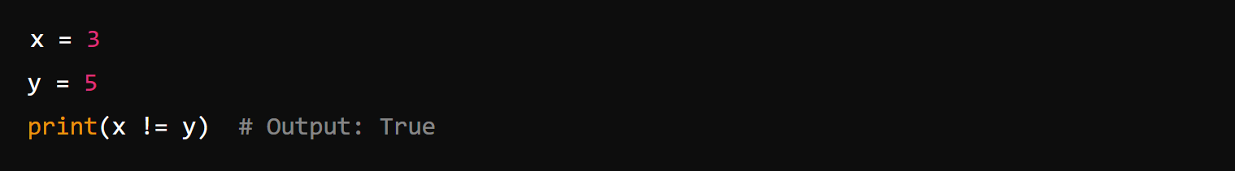
- Greater Than (>)
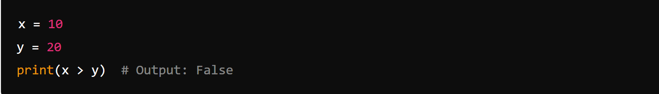

- Greater Than or Equal to (>=)
- Less Than (<)
- Less Than or Equal to (<=)
1.4 Logical Operators
Logical operators are used to combine conditional statements.
- AND
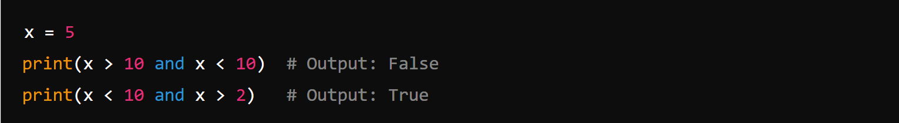
- OR
- NOT
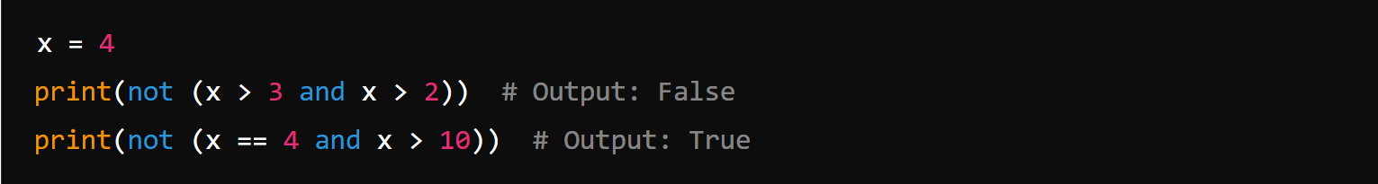

1.5 Membership Operators
Membership operators are used to test whether a value is found within a sequence (such as a list, tuple, or string).
- in
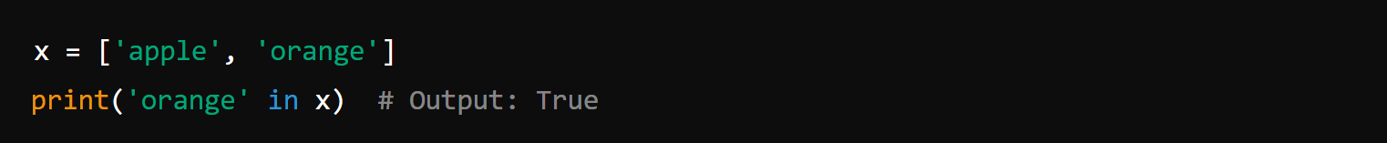
- not in

2. Conditional Statements
Conditional statements allow you to execute code based on certain conditions.
2.1 If Statement
- Basic If Statement
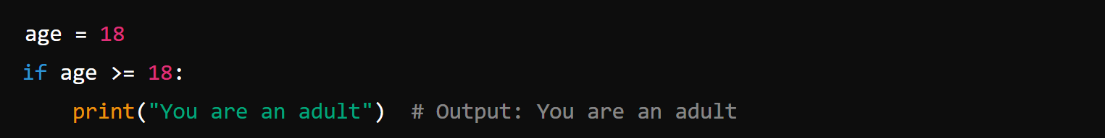

- If-Else Statement
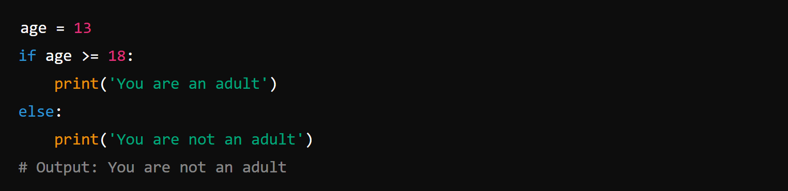

- If-Else with User Input
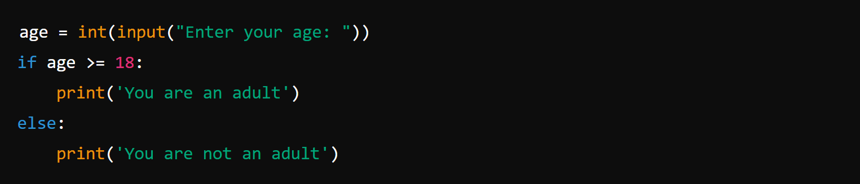
2.2 Elif Statement
- Elif Example
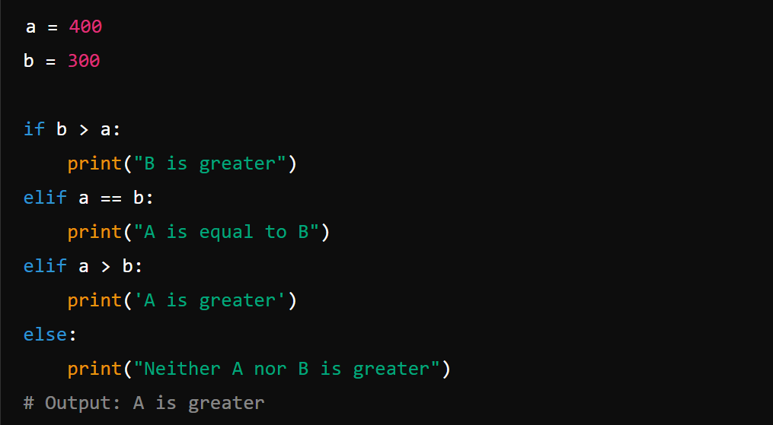
- Elif with User Input
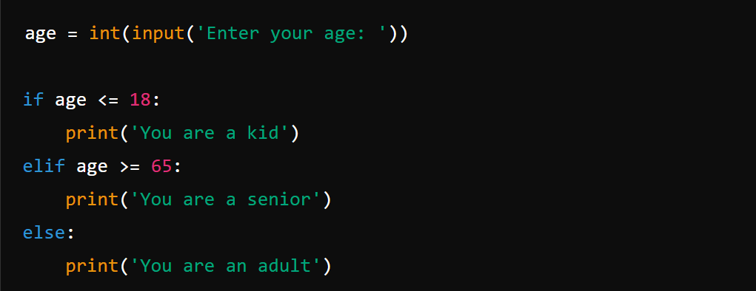

3. Loops in Python
3.1 While Loop
Executes a set of statements as long as the condition is true.
- Basic While Loop
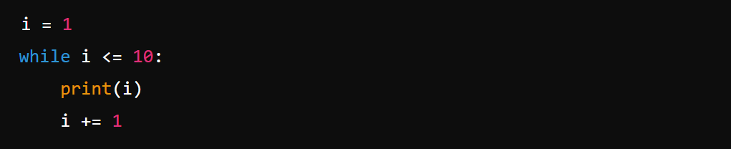
- User Input Loop
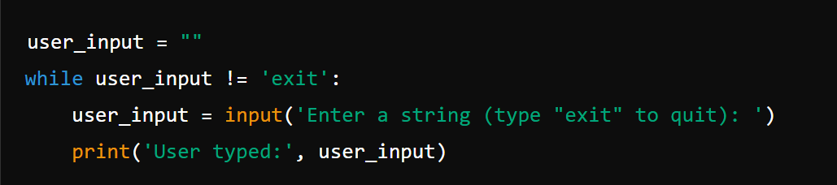

3.2 For Loop
Used for iterating over a sequence (like a list, tuple, or string).
- Basic For Loop
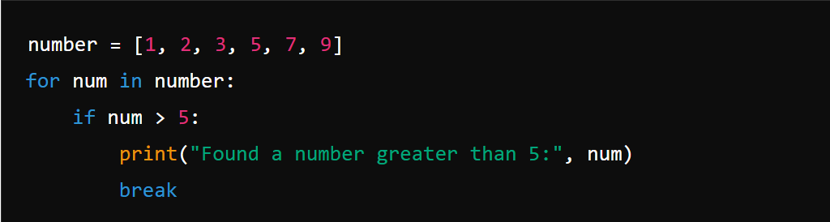

3.3 Break Statement
Used to exit a loop before it has looped through all items.
- Break in While Loop
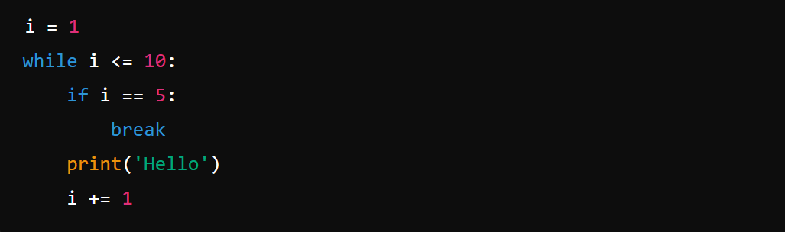

- Break in For Loop
